

Risk Assessment

As part of managing health and safety within the University, risks in the workplace, on campus and in work activities must be effectively mitigated and controlled. To do this, thought must be given to what might cause harm to the university community and what reasonable pragmatic steps are taken to prevent that harm from occurring. Completing a risk assessment will assist in deciding whether there are suitable and sufficient controls in place.
NOTE: All Risks that are rated at HIGH or 12 and greater must be reported to the Health Safety and Compliance Team.

Assessment Date: |  |  |  |  | Review Date: |  | Maximum 1 year from assessment date |  |  | RISK EVALUATION TABLES
Faculty / School / Service / Team: |  |  |  |  |  |  |  |  |  |  | 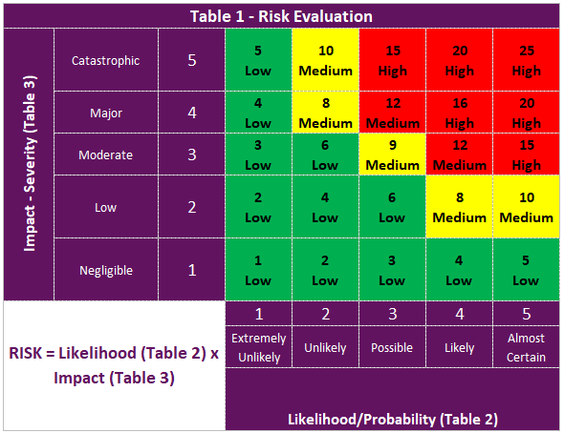
Site / Building / Area:
Description of Assessment i.e. task and / or activity:
Assessor Name(s) Include all those who were part of the development of the Risk Assessment: |  |  |  |  | Assessor(s) Sign Off:
Responsible Person i.e. Line Manager/Head/Faculty Manager/Tutor/Course Leader: |  |  |  |  | Responsible Person Sign Off:
Number of High Risks (i.e. 12 and above): |  |  | Number of Actions: |  |  |  |  |  | 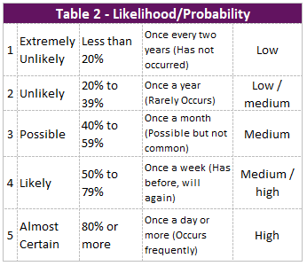 |  |  |  |  | 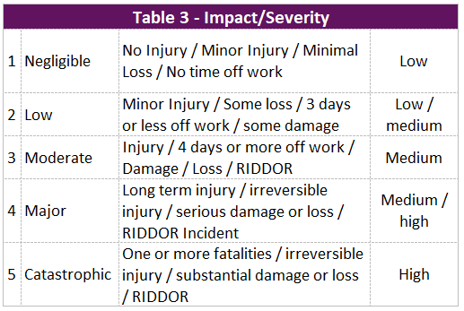

Risk Assessment

Ref | Hazard(s) | Who might be Harmed? | How could they be harmed? (Risk) | Risk Level |  |  |  | Further Additional Controls (Actions)  (What further action needs to be taken / what can be done to reduce the risk further)
 |  |  |  | LH – Likelihood, IP – Impact, RR – Risk Evaluation
 |  |  |  | Existing Controls In Place  (What are you already doing to control the risks) | LH | IP | RR

Action Plan

Total No of Actions: |  |  | Actions Completed: |  | Actions in Progress: |  | Actions Not Started:
Ref | Action(s) Details (This should reflect all the further additional controls highlighted in the above table) |  |  |  |  |  |  | Remedial Action Owner |  | Target Date |  | Status | Comments / Updates

